EXPERIMENT 9:

To design and implement the two bit half adder using Logisim simulator.

**TRUTH TABLE:-**

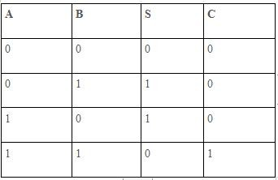

S = A XOR B . C = A AND B .

CIRCUIT DIAGRAM:

